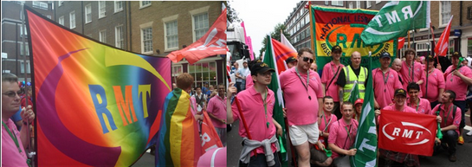
LGBT Members to March at Tolpuddle Festival

The festival runs from 13-15th July 2012. The rally is on Sunday 15th July. Regional councils usually organise coaches to get members to and from the rally on the Sunday. Why not join us? Help carry the banner or walk with us for the rally on Sunday.

For more information on marching with the LGBT banner contact us via the RMT LGBT Facebook group.

Dates for Your Diary

- Advisory committee meetings
  - 2nd July at 1300 Unity House
  - 8th October at 1300 Unity House
- TUC LGBT Conference
  - 5th – 6th July
- Tolpuddle
  - 13th to 15th July
- Pride
  - World Pride, London – 7th July
  - Manchester – 25th August
  - Newcastle Pride 21st July
  - Sunderland Pride 22nd Sept

Contact Us - Email the Equalities Officer Jess Webb at j.webb@rmt.org.uk.
We’re on Facebook too – search for ‘RMT LGBT Members’
Standing Proud

“LGBT workers of the world unite”

RMT Lesbian, Gay, Bisexual & Transgender News
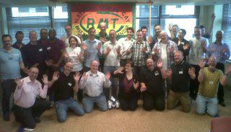
RMT LGBT Conference

Report by Jo Parry, May 2012.

A total of 23 delegates took part in this year’s conference the largest delegation that I can recall in the last few years. (29 were registered to attend). Seven delegates were from London Transport Region. Four female delegates were on the list to attend; however, I was the only female delegate to attend.

Tony Parris, from South Hants branch was a brilliant host, welcoming everyone with a great pre-conference social in London Hotel and even led the Karaoke. It’s was a shame the conference venue’s lunchtime spread was not a patch on that from the night before.
Conference even started with a power cut in the hotel but we pressed on.
The original conference chair did not attend but luckily the vice chair Paul Blair was a dab hand at it when he took the hot seat for the proceedings.

Bob Crow – General Secretary
A speech from Bob Crow started the conference.
Bob spoke the need to organise against the findings of the McNulty report. He explained how when a franchise changes the tenders will automatically be changed to say no guards or catering staff on trains, and yet when you are stuck in a crisis and need help evacuating a train who are the ones to primarily help you out? - Oh yes the guard and the catering staff!
McNulty report also said that the industry overpays and suggests the increasing of fairs whilst services are slashed. Bob stated this is why we should be running passenger awareness campaigns as “no passengers = no jobs”.

Bob then went on to discuss if Greece defaults it will affect anyone in the UK with a pension as banks invest our money in Greece and so pension pots could decrease by 10-15%.

Next Bob explained the changes to employment tribunal (ET) claims.
Bob then spoke about the government removing the union learning fund. He said that RMT recognised the importance of giving working people the opportunity to move up the ranks and so they are hoping to set up a Union Advisory Committee that will look at what we should do for learning/education.

Bob explained that as part of the union’s commitment to education work is underway on creating a further 8 bedrooms at Doncaster Education Centre which means that an extra 400+ reps could be trained there in a year (depending on the length of the courses).

Bob said that they are also looking at the practicability of placing all legislation and updates for reps on kindles that could then be loaned from Unity House to reps to be kept abreast of changes.

Bob explained how union rep facilities time is currently paid for my employers – this is being removed and so the union will need to pay for release of reps to conduct duties and pay reps if they need to attend a staff side meeting.
Bob also spoke about the advantages of a credit union (external site) account over a bank account.

Janine Booth – EC report
Janine talked through progress of last year’s conference resolutions; handing out a copy of the new look membership form which now includes sexual orientation - which includes heterosexuality too.

For those wondering what happens with the information, there has been a guarantee that this information will not appear on starters/leavers lists or on branch secretary lists or forms. For existing members the website has been amended so you can update your information in the membership section.

LGBT history resolution – they are still collating the information/stories that have been submitted and will issue something in autumn.

‘’Homophobia at work’ posters have been produced and Janine discussed that we need to be asking ourselves why cultures that tolerate homophobia exist in the workplace still.

Janine said she believed “there are no individual cases; we should view it as an individual example of a collective case”.

DVD resolution – DVD has been produced. (As submitted with the report) and it is also available to be viewed on RMTV.

Other speakers were:
Phil Boston – Organising Unit

Mark Healey – 17-24-30.org

Richard Chapman-Harris – BTP LGBT

Forum (LINK-LGBT Vice-Chair)

Motions
- International LGBT Rights
- RMT National LGBT Advisory Committee
- Diversity Role Models – tackling homophobia through education
- Aviation industry forced gay flight attendant into a sham marriage
- Campaign for Equal Marriage
- ‘Gay Cure’ adverts on TfL Buses

All resolutions were passed at the LGBT conference. Two of them –‘International Homophobia’ and ‘Diversity Role Models’ were also voted to go to the RMT’s annual general meeting.
They have since both become union policy having been unanimously voted for at the AGM.

Conference 2013

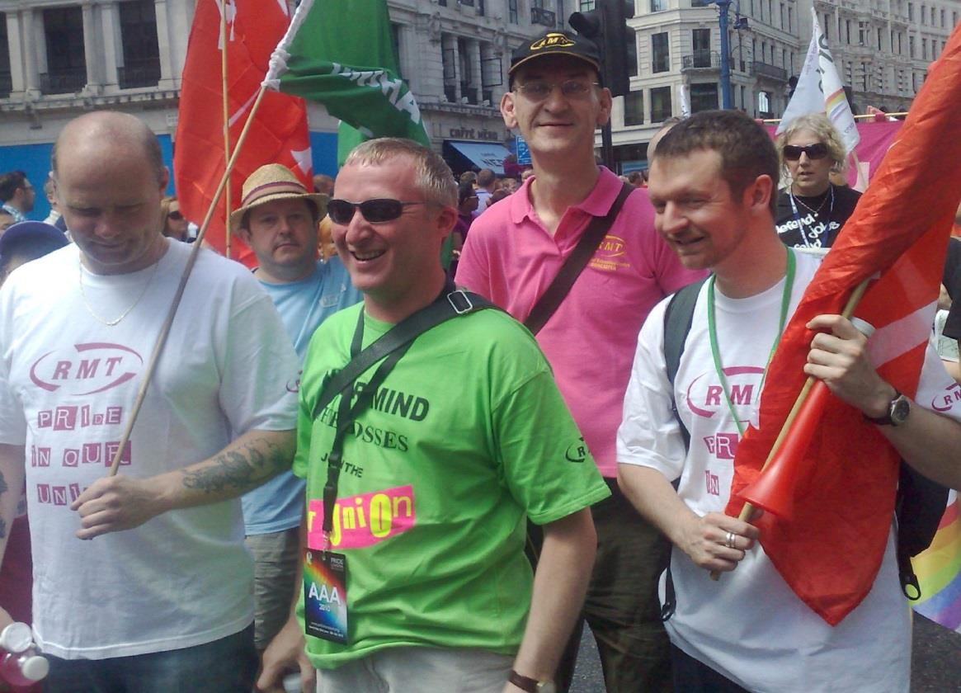
Next year the Lesbian, Gay, Bisexual and Transgender conference will be held in Blackpool. We want to get even more delegates to attend than this year to keep the RMT LGBT movement growing. Another priority is that more resolutions on LGBT issues are put forwarded.

To pass a resolution, first submit it to your branch. If passed it can then go to the LGBT advisory committee, your local regional council meeting, or be submitted to the next LGBT conference and possibly even to the annual general meeting for members across the country to debate.

Is there a homophobic attitude at your workplace? Inequality for LGBT workers people that needs to be addressed? Take action by submitting a resolution about it to your local RMT branch.

Bob Crow to Join Members at LGBT World Pride

On 7 July 2012 visitors from around the world will join one million people on the streets of central London to celebrate World Pride 2012 – the largest ever LGBT Pride festival in the UK. RMT will be supporting the TUC’s section of this festival in promoting trade unions to the LGBT community and the wider world as champions of LGBT equality.

ALL MEMBERS ARE WELCOME TO ATTEND PRIDE WITH US

To make the most of this opportunity to boost profile and membership, our LGBT Advisory Committee invites all members to join them and take part in what will be a truly memorable and enjoyable day. Everyone is welcome to join in the RMT section of the walking parade – and I will be there too. Volunteers are also needed to staff the stall which is most likely to be on Trafalgar Square.
Please do use the attached poster to advertise the event. For any queries or to say you wish to take part, contact our Equal Opportunities Officer (j.webb@rmt.org.uk).

Don’t forget we are on Facebook –search for ‘RMT LGBT Members’ and join us.

LGBT Motions Pass Unanimously at RMT Annual General Meeting

Both resolutions sent from this year’s LGBT conference to the AGM have been unanimously passed. They now become national union policy. These resolutions started when they were submitted by a member at their branch meeting. If you have an issue you’d the RMT to debate then why not do the same yourself?

International LGBT Rights submitted by Stratford No.1 Branch:

“This conference notes:

- The speech by United Nations Secretary General Ban Ki-Moon on 7th March 2012 calling on all countries around the world to decriminalise consensual same-sex relationships and end discrimination against LGBT people.
- That in 76 countries being gay is illegal, and in 10 of these, punishable by death or life imprisonment.
- LGBT people in regions around the world are victims of violence, such as targeted killings, violent assaults and torture.
- The Russian city of St Petersburg has recently passed a law making it illegal to speak in public about being LGBT.
- Across Africa, parliaments are advocating laws that would further penalise, even execute, gay people.
- In Iraq, religious militias have brutally murdered hundreds of gay men and young men perceived to be gay.
- The Iranian theocratic regime criminalises and oppresses homosexuality.

This conference believes that:

- Human rights are for all people, in all countries.
- Proposals to cut aid to countries with anti-gay laws may be counterproductive and are generally not supported by LGBT groups in those countries.

Conference calls on the RMT to:

- Support campaigns against homophobia around the world.
- Build solidarity links with LGBT rights campaigners and trade unionists
around the world.
- Support and mobilise for appropriate protest actions.
- Raise the issue of LGBT rights at international events that the union attends.
- Continue to support LGBT workers and trade union rights in countries such as Iran, while opposing military action against them.
- Include a feature on international LGBT rights in RMT news.”

Diversity Role Models: tackling homophobia through education
submitted by Finsbury Park Branch:

"This union is appalled that:
Lesbian, gay, bisexual and transgender (LGBT) young people are three times more likely to attempt suicide
Two thirds of LGBT young people suffer bullying at school which leads to lack of focus on learning and achievement
Straight students are terrified of being called 'gay’; which leads to girls dropping out of sport and boys hiding their artistic talent to conform to gender roles and avoid being labeled gay or lesbian.
In schools where homophobic bullying is tackled, lesbian, gay, bisexual and transgender (LGBT) students are 60% less likely to be bullied, preparing students for a working environment in which homophobia and transphobia are not tolerated and diversity is respected.
This union commends the good work by Diversity Role Models who actively seek to prevent homophobic and gender based bullying in United Kingdom schools by educating all young people about differences in sexuality; communicating with students directly, using positive role models (LGBT and heterosexual) to counter negative stereotypes.
This Conference requests the Council of Executives to consider:
- Fostering a working relationship with the charity Diversity Role Models, financially (where possible) and also publishing details of their work via an article in RMT News
- Organise a support function open to all RMT members who experienced homophobic bullying at school or members whose children are experiencing homophobic bullying at school
- Contact teacher and other education trade unions asking what their policies and activities are on this issue
- Run political campaigns to oppose cuts in funding to anti-bullying initiatives"

