DISABLED TRANSPORT WORKERS AND THE COVID-19 CRISIS
- a message from RMT
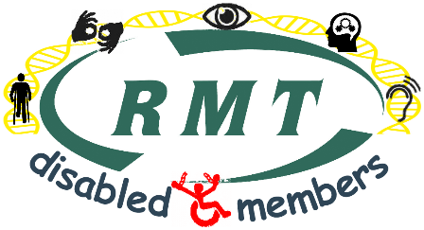
Disabled transport workers are a significant and valuable part of the workforce that delivers transport to millions of passengers and freight consignments every day. Many of us are also particularly vulnerable during the current Covid-19 pandemic.

While some people still say that there is little to worry about because ‘only’ the vulnerable are at serious risk, we remind them that many disabled transport workers are among those vulnerable people. Other transport workers have caring responsibility for disabled dependants.

RMT is calling on transport employers to:
- guarantee that anyone who stays off work following government advice does not suffer loss of pay or disciplinary action
- allow people to work from home where practical
- ensure that all workplaces are fully stocked with all necessary hygiene products, and that cleaning regimes are enhanced
- reduce the transport service where appropriate
- withdraw work duties that involve unnecessary social contact eg. ticket-checking
These measures must apply to all workers, not just disabled workers, as they make the workplace safer for all of us - and for our passengers.

While some employers have taken some of these measures, not all have. We are particularly concerned that many outsourced staff, such as cleaners, are being economically coerced into attending work by not being offered paid special leave or full sick pay. This deplorable situation puts everyone at risk, and must end immediately.

The current situation is causing great anxiety to many of us, and the isolating measures that we have to take may have a negative effect on people’s mental health, perhaps especially those with mental health conditions and disabilities. People need support and solidarity.

What to do during this crisis:
- if you have any questions or concerns, contact your RMT rep, health and safety rep and/or branch official, or phone the union’s helpline on 0800-376-3706
- follow the government’s advice.to protect yourself and others: http://www.nhs.uk/conditions/coronavirus-covid-19/
- exercise your right to refuse to carry out work that puts you or others in serious and imminent danger - details here: https://www.rmt.org.uk/news/publications/serious-and-imminent-danger-booklet/
- support your workmates and your community, recognising that some are particularly vulnerable
During this time, trade unions are as important as ever – perhaps even more so. RMT Disabled Members are will continue to organise, using alternative (such as online) media. You can keep up-to-date with this by:
- joining our Facebook group: RMT Disabled Members (open to all RMT members)
- checking the RMT London Transport Region’s disabled members webpage here: http://www.rmtlondoncalling.org.uk/disability
- checking the RMT London Transport Region’s coronavirus webpage: http://www.rmtlondoncalling.org.uk/coronavirus
- contacting RMT London Transport Region Disability Officer, Janine Booth j.booth@rmt.org.uk
Janine Booth
RMT London Transport Region Disability Officer

