12-WEEK ‘SHIELDING’
RMT London Transport Regional Council Disabled Members Covid-19 Bulletin no.3 – 26 March 2020

Government advice is for people considered to be ‘extremely vulnerable’ to Covid-19 to ‘shield’ (stay at home with no contact with anyone other than carers) for twelve weeks. The government specifies that this group includes:
1. Solid organ transplant recipients.
2. People with specific cancers:
n people with cancer who are undergoing active chemotherapy or radical radiotherapy for lung cancer
n people with cancers of the blood or bone marrow such as leukaemia, lymphoma or myeloma who are at any stage of treatment
n people having immunotherapy or other continuing antibody treatments for cancer
n people having other targeted cancer treatments which can affect the immune system, such as protein kinase inhibitors or PARP inhibitors
n people who have had bone marrow or stem cell transplants in the last 6 months, or who are still taking immunosuppression drugs
3. People with severe respiratory conditions including all cystic fibrosis, severe asthma and severe COPD.
4. People with rare diseases and inborn errors of metabolism that significantly increase the risk of infections (such as SCID, homozygous sickle cell).
5. People on immunosuppression therapies sufficient to significantly increase risk of infection.
6. Women who are pregnant with significant heart disease, congenital or acquired.
Keep up-to-date with NHS advice here: www.nhs.uk/conditions/coronavirus-covid-19/
RMT is working hard to ensure that anyone in this situation can carry out government advice without fear of losing money or being disciplined. If you are in one of these groups and your manager does not accept that you stay away from the workplace on full pay and without threat of disciplinary action, then show them this bulletin, and contact your RMT rep.
Please note that these are not the only categories of people who need to stay away from work.
This bulletin is only about those in this particular designation; if you are not in one of these groups, that does not mean you should be at work.
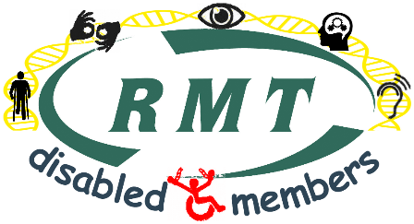
Janine Booth
Disability Officer
RMT London Transport Region
www.rmtlondoncalling.org.uk/disability

