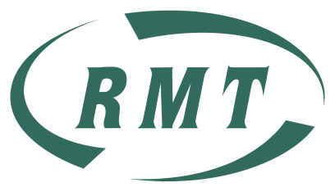

Displacement Letters Have Been Issued

You Have Until Mid-May to Request a Review

RMT Advice is: Hold Tight

We are still discussing the review process with LU. We will issue further advice in good time to apply for review. Moves are due to take place in 2016.

RMT is Fighting For:

* More Jobs on Stations
* Fair Rosters with more Weekend Rest Days
* Minimising Displacement & its Impact

For advice on the review & appeal process

contact your Local RMT rep:

NAME and Phone No

Stations & Revenue

Functional Council

31.4.15